Automated Gardening

User Manual

Name : Mahantesh Patil

Course: COEN 275

The Database used for this application is MySql. So I have attached the MysQl dump file in the submission.

I used the below command to generate the dump file.

C:\>mysqldump -u root -p gardening > gardening.sql

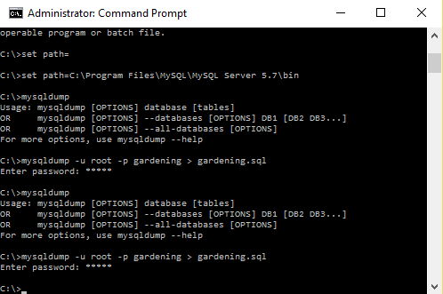

Steps to download the MySql table:

* Create a database named “gardening” in MySQL server.
* Use the below command to use the table created in that file.

C:\>mysql -u root -p gardening < gardening.sql

Once the table is imported, Starting the Application:

Use the Command

* java -jar gardening.jar

On start the application asks for the username and password. Please provide username and password of your MySQL server installation.

Below is the Screen Shot.

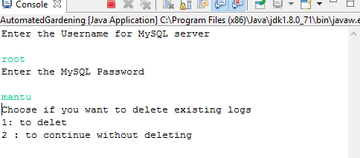

The Application provides simple easy to use interface to navigate through different services available and persists all the activities in MySQL database.

Below is the sample screenshot of the interface and the logs generated.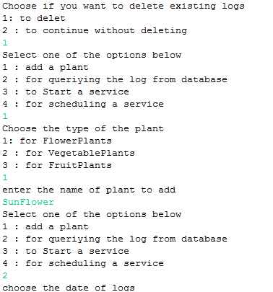

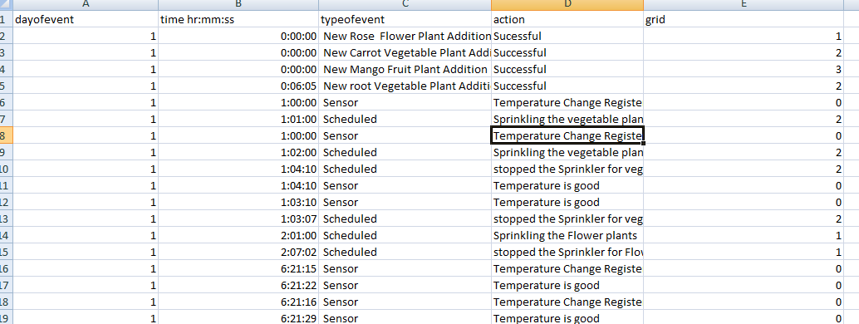

Automated Gardening application contains mainly 5 different modules namely database , garden, garden controller , garden service controller and scheduler.

Garden service controller again has 4 other modules representing water system, Heating System , Fertilizer and Pesticide controller system.

This application divides the garden into three grids accommodating Flowers, Fruits and Vegetable Plants. Each grid can have maximum of ten plants.

Timing model used hers is 24 hour model and the application always starts from 1st day at 00 hours. Every time application is stopped it again starts from first day. So every time application is started there is option to delete the existing logs so that the old logs do not interfere with new ones.

Users can perform following actions:

-Add plants.

-Add and modify scheduling plan.

-Check logs based on date.

-Start a service.

Application can automatically perform the tasks as scheduled and even cancel or modify the schedule based on the weather conditions. For example whenever it rains the sprinklers scheduled for 24 hours will be cancelled and whenever pests attack pesticide will be sprayed automatically. Users will also be warned when starting inappropriate service at inappropriate time.

The system has the plans scheduled for first 10 days, the user can add plans for days after that and only three plants are present in the garden, which can also be added by the user. Upto 30 plants can be added, 10 of each type.